Reservation form for Adams Beach Hotel & Spa (5*)

FMARC 2024 - June 16-18, 2024

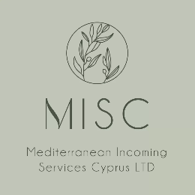

Mediterranean Incoming Services Cyprus (MISC) Ltd is designated as the hotel agent to assist conference delegates in arranging their hotel bookings for the event.

BOOKING DETAILS:
Arrival Date: |  |  |  |  | Departure Day: |  |  |  |  |  |  | Number of Nights:
Arrival Time: |  |  |  |  | Departure Time:
Please indicate type of room required (rate is per room, per night, on Bed and Breakfast, inclusive of VAT)
 | Single room on Bed & Breakfast €230.00 per room per day
 | Double room on Bed & Breakfast €240.00 per room per day
 | For additional nights before or after the even the same rates as above will apply. Special rates for families with children. For more information & questions: karolos@miscyprus.com.
PERSONAL DETAILS:
TITLE:
FIRST NAME: |  |  |  |  |  | LAST NAME:
INSTITUTION:
CITY: |  |  |  |  |  | COUNTRY:
MOBILE: |  |  |  |  |  | FAX:
EMAIL:
Check-out time is 12:00, but if anyone requires late check out (upon availability) extra charges will apply.
Hotel accommodations must be paid directly to MEDITERRANEAN INCOMING SERVICES LTD. Reservations should be paid in full by 12 April 2024. Reservations cancelled on or before 12 April 2024 will not incur a charge. All cancellations must be submitted in writing. In the case of no-shows, a full cancellation fee will be charged. Bank details for payments will be provided along with the accommodation confirmation.
RELEASE DATE FOR HOTEL RESERVATIONS:
Please note that the above rates applied for all bookings made before 12 April 2024. After this date no room availability can be guaranteed, and higher rates might be applied for ANY bookings made.
Date: |  |  |  |  |  |  | Signature:

Please return the completed and signed form to karolos@miscyprus.com and carbon copy (Cc’d) it to conf2024@fmarc.eu before 12 April 2024.

